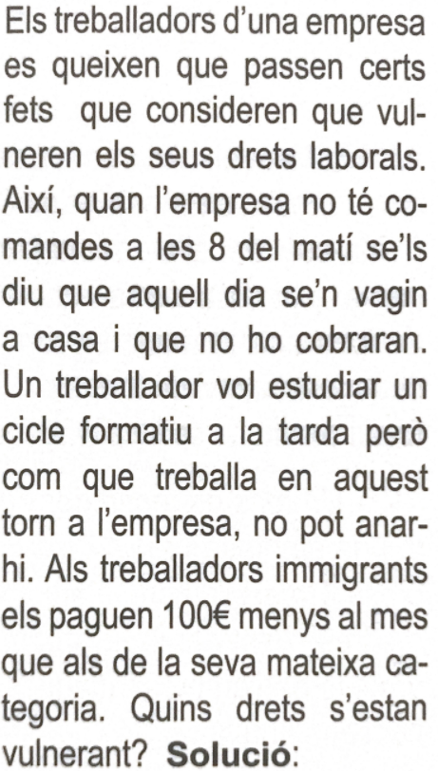

1. If the worker cannot provide his services because the employer does not give him a workload, and it is not because of the worker, but because of business activity, the worker will continue to have the right to receive his salary even if he is not working.

Since the worker also have the right to have workload, the company have two options in those cases: they can give another job for that day, or also they can give holiday days, in this way, workers do not have to go to work if they have nothing to do. It is a good solution if the situation will last a short time.

1. According to the 23 article of the Status of workers, all workers have the right to get its normal shift adapted for the correct assistance to its professional formation or courses.
2. Knowing they are legal immigrants, according to the law they are Spaniards, so they are protected with the 14 article of the Spanish constitution:

All Spaniards are equal before the law, without any discrimination based on birth, race, sex, religion, opinion or any other personal or social condition or circumstance.

Also, if they are not legal, they just can’t legally work.